 | ​ | 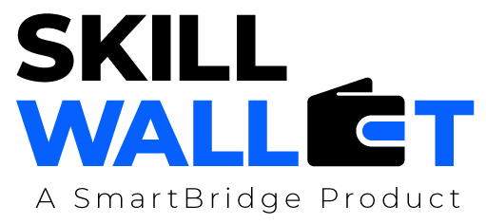
Communication
Date | 15 March 2026 2 July 2026
Team ID | XXXXXX EduGenie - Google Gemini Powered Learning Assistant
Project Name | XXXXXX EduGenie - Google Gemini Powered Learning Assistant
Maximum Marks | 1 Mark
Communication Plan:
Effective communication is essential for a successful project demonstration. This document outlines the communication strategy used within the team and with stakeholders throughout the project lifecycle, including how updates, issues, and feedback were managed.
S.No | Communication Type Team Standup | Frequency Daily | Channel / Tool  WhatsApp / Google Meet | Participants  eet All members | Purpose  Sync progress and blockers
1 | Team Standup Progress Update | Daily Weekly | Google Meet | All members | Review sprint progress against backlog backlog
2 | Progress Update Issue Discussion | Weekly As Needed | GitHub Issues / WhatsApp | sApp Relevant members | bers Triage and resolve  implementation bugs implementation bugs  Get feedback on architecture
3 | Mentor Review Issue / Bug Discussion  Demo Rehearsal | Bi-Weekly As Needed  Once | Google Meet  Google Meet | Team Lead +  All members | entor and progress and progress  Rehearse the live project  demonstration
4 | Stakeholder Review | Bi-Weekly |  |  | demonstration
5 | Final Demo Rehearsal | Once
6
Communication Challenges & Resolutions:
S.No | S.No Challenge Faced | Resolution / Action Taken
1
2
3

